INTERNATIONAL ORGANISATION FOR STANDARDISATION
ORGANISATION INTERNATIONALE DE NORMALISATION
ISO/IEC JTC1/SC29/WG11
CODING OF MOVING PICTURES AND AUDIO

ISO/IEC JTC1/SC29/WG11
MPEG2016/N15996

February 2016, San Diego, United States

Source: Communications Group
Status: Approved
Title: White Paper on MPEG-21 Contract Expression Language (CEL) and MPEG-21 Media Contract Ontology (MCO)
Authors: Jaime Delgado, Silvia Llorente (DMAG-UPC),
Laurent Boch (RAI) and Víctor Rodríguez (UPM)

Table of Contents
1. INTRODUCTION 1
2. bUSINESS SCENARIO 3
2.1 Business case example 4
3. basic structure of media contracts 5
4. benefits of machine-readable media contracts 7
5. possible uses of cel / mco 8
6. conclusions 10
annex a. mpeg-21 addressing media contract formalization 11
A.1 Cel and its xml based format 11
A.2 Mco and its owl based format 12
references 14

White Paper on
MPEG-21 Contract Expression Language (CEL) and
Media Contract Ontology (MCO)

Jaime Delgado¹, Silvia Llorente¹, Laurent Boch², Víctor Rodríguez³
¹Distributed Multimedia Applications Group,
Computer Architecture Department,
Universitat Politècnica de Catalunya (DMAG-UPC)
²Radiotelevisione Italiana Spa (RAI)
³Universidad Politécnica de Madrid (UPM)

Abstract: Media contracts specify business agreements between two or more parties transacting digital media or providing services around media content. Media contracts are the documents in which the rights on exploitation of media content, object of trades, are formally expressed. Activities with media content requiring rights holding must be checkable against such media contract clauses. This to be effective in nowadays digital domain requires electronic machine-readable formats. The MPEG-21 Contract Expression Language (CEL) and the MPEG-21 Media Contract Ontology (MCO) have been developed with this aim. They are part 20 and part 21, respectively, of MPEG-21 (ISO/IEC 21000-20, ISO/IEC 21000-21). On the one hand, CEL defines a language for representing media contracts with XML. On the other hand, MCO defines a language for representing media contracts as ontologies with OWL. Both take into account the needs of the media contracts, but bearing in mind other application scenarios, thanks to the extension mechanisms they provide.

Keywords: Contracts, Media, MPEG-21, Rights Management, Rights Exploitation, Trade of Rights

- Introduction
If there are questions that you should be able to answer, but you cannot accurately enough, about what rights are usable by your company on media that your company holds, you should probably wonder if the tricky rights management issue is sufficiently under control.
The domain of audiovisual rights was not that complex until years ago. Have you been keeping records on a shared Excel spreadsheet? Or was it just that folder of paper documents in the drawer?
You were used to meet your partners, always the same ones, face-to-face. How many details on agreements, variations and solutions to possible controversies have been just discussed at the restaurant, and a memo was written on a paper napkin?
Maybe you are involved in broadcasting, media communication, digital publishing and/or video or music production. You might be an artist yourself, an author or a performer. Moreover, you might be an agent managing the business for any of the above. Or you might be an information technology (IT) service provider for any of the above (see Figure 1). Whether you are on the technology side or on the business side regarding audiovisual rights management, this white paper is for you.
Figure 1. Business actors on media rights
Technology is a key issue in this discussion. New technologies have completely changed our world and our lives. In particular, the biggest changes involve the way people communicate. Many communication aspects have merged, thanks to new technologies, creating a lot of new opportunities, new ways of having fun, getting informed, being involved in the society; but they have also brought us some confusion.
The change has been particularly relevant in the increasing number of produced / exchanged / consumed media items, delivery means and modalities, fruition device types, users acting either as producers or consumers, and typologies of rights defined in the media contracts. Besides, old barriers to media fruition, such as language, country borders and access to technology (also in terms of price), have progressively become less important.
However, intellectual property concept is there, especially when people want to exploit media in order to run business and earn money. There are people and organizations holding rights over media assets either because they are the authors or creators or because they bought rights from other rights holders.
So, why rights are an issue? Why everything improves but rights? Why rights, in some cases, become the bottleneck of the media business? Things can change and improve also in the domain of rights, but let’s analyze some of the problems that people working on rights have to deal with daily.
Companies handling audiovisual content generally enter into many different contracts, and managing them is critical and sometimes challenging. Over time, contracts in a variety of formats accumulate (paper contracts, scanned pdf, pdf coming from word processing tools, etc.), and companies need to access them in a digital and homogeneous form. Thus, different collectives -including broadcasters, libraries, authors, agents, producers, and so on- need to digitalize contracts for various purposes. However, the narrative contracts, even in digital format (i.e. scanned pdf file), are often written using legal terminology. Complex sentences are conceived for defining clauses, the complexity of which reflects the facets of negotiation. The rights are split into smaller and smaller pieces, in order to increase revenues by selling every piece to various distinct customers under different conditions.
Some people complain about intellectual property laws. However, such laws do not define the exploitation rights into much detail. In fact, rights become small (restricted) because the contract parties use to define conditions, restricting the possibilities to exploit the rights, in many different ways. On the one hand, trading media rights can create good revenues, but on the other hand, keeping knowledge and tracking on all the rights might result to be expensive.
Attempts to put order in the chaos of rights have already been made. Most of them are based on the translation of rights defined within narrative contracts into structured information held by database systems. Usually, this implies the definition of taxonomy of rights and adopting common sense, such as having an expiration date field for metadata.
Different previous attempts to formalize machine-readable contracts, as [1], have achieved varying degrees of success. In any case, they all have had to face a common set of difficulties:
- translation from narrative legal to check boxes is not easy; people working on that task require skills and sometimes they need legal advice, not always consistent;
- the taxonomy used sometimes is not flexible enough; when new cases appear, they are difficult to map; important information is left to textual notes, that stay machine-unreadable;
- definition of the adopted taxonomy terms might still be ambiguous; when such rights systems are adopted by only one party of the contract, the other parties may refuse to recognise the output, in case of controversy.
Today, electronic contracts are interpreted in broad terms, and they are required to guide different workflow systems across different organizational business processes and different companies, thereby granting business integration over electronic networks.
To sum up, what if an electronic format for media contracts is defined? First of all, it is needed to move the rights management process forward from being the bottleneck of the media business. Moreover, it will provide the following advantages:
- to have formats for machine-readable unambiguous documents on rights and media contracts;
- to have legally binding documents which can be used as evidence to prove acceptance of liabilities;
- to facilitate the integration of contract services in existing multimedia content management platforms; and
- to guide different workflow systems across different organizational business processes and different companies, thereby granting business integration over electronic networks.
The technologies supporting machine-readable contracts presented in this document are ISO/IEC 21000-20, i.e. MPEG-21 Contract Expression Language (CEL), for XML based environment [2] [3], and ISO/IEC 21000-21, i.e. MPEG-21 Media Contract Ontology (MCO) [4], that uses also ISO/IEC 21000-19, i.e. MPEG-21 Media Value Chain Ontology (MVCO) for OWL based environment [5].
The next clause describes some use cases and scenarios where MPEG-21 CEL and MCO can be applied in order to show the benefits provided by a machine-readable format for contract management.
- Business Scenario
Media contracts have been developed to model the actions and conditions that relate several actors in the trading of audiovisual material (content) or services working with audiovisual material. By audiovisual material we mean movies, television series and programmes, photographs, music, books (digital or not) or learning material, including both digital and non-digital formats. Depending on the type of media to be traded, different actors come into play, like broadcasters, producers, editors, music companies, singers or authors. Services include those that can be associated to multimedia content like transferring, packaging, protecting or converting content.
Taking the above into account, various possible contexts of use exist for media contracts, all along the business domain’s media life cycle, which include:
- media creation, involving the authors and the production companies;
- media delivery, involving broadcasters and distribution and telecommunication companies;
- archive, which holds the content at disposal for reuse in new productions or for exploitation as is.
  - Business case example
Based on both media and actors, we can identify a set of business cases. We are going to present in detail the example of an agreement between broadcasters, while giving hints on how other possible business cases could be detailed as well.
This use case involves two or more broadcasters who agree on some terms and conditions for the broadcasting exploitation of a TV programme. The conditions may involve the definition of the territory (country and / or region, in the example, Spain) where the programme can be offered by one of the two broadcasters, assuming that the other one was holding that right, or wider rights, on the programme. Also the means (DTT, Internet, in the example, Broadcast) could be defined and the time span when the programme will be available for the public (in the example, November 2015). Other conditions, like the number of times the right can be exercised (in the example, 3 times), can be also indicated. Figure 2 illustrates this business scenario.
Figure 2. Broadcasters’ Agreement
It is worth noting that other business cases could be represented in a similar way. For instance, one can model the business relationship between a broadcaster and a video producer for broadcasting a TV series, the distribution of learning material between an author and a publishing house or the distribution of music done between a musician and a music company. Different conditions (country, means, time span, etc.) can be defined to meet the needs of the parties involved in each business relationship.
- Basic structure of media contracts
If you look at real narrative media contracts, as the experts who have developed the MPEG-21 technologies did, you will find that almost all of them share a common structure that consists of a header or preamble and a body. The preamble contains:
- contract metadata (date, version, title, and so on);
- unique identifier of the contract;
- possible relationships with other contracts, like amendments, prevalence or substitution;
- the parties involved, possibly identified by their public key; and
- a set of declarations - that is, statements that the parties recognize as true.
On the other hand, the body’s structure includes, at least, the following specific information for the contract:
- the object of the contract (content or service);
- the operative part containing the contract information - that is, deontic expressions such as permissions, obligations, and prohibitions. These clauses include the right (action), the media (digital or not) which is the object of the right and the conditions that must be satisfied. They are related to the parties of the contract and can be related among them (for instance, a party has an obligation of payment after broadcasting some media as specified in one of the contract’s permission). We also call the conditions facts, because they can be regarded as logical statements inside a clause that can be even combined using union and / or intersection operators. All facts inside a clause must be true, i.e. have to be satisfied.
Finally, contracts are accompanied by other provisions, such as warranties, legal disclaimers and termination clauses. Figure 3 shows this basic contract structure.
Figure 3. Basic contract structure
Your experience in the media contract domain would certainly raise other needs that you expect to be addressed by electronic contract features. Among them, the need to keep the contract confidential is met by the possibility of encrypting either the whole contract or any part of it. In addition, to support other contract-based services, it should be possible to use contract templates, as well as to be able to distinguish between contract offers and signed contracts; other requirements, such as support of the contract negotiation process, and track of the contract management along its life cycle were also identified.
The rights and conditions used in media contracts include, among others, the following exploitation rights:
- rights for communication to the public (from a single place where the public is not present, by broadcasting, or otherwise making the work available);
- fixation rights;
- distribution rights;
- reproduction rights;
- transformation rights (all forms of modification); and
- public performance rights (the work is showed or played in public).
When permitted, such actions correspond to wide powerful rights that are usually restricted by requiring a number of conditions.
Some of the conditions present in contract clauses are:
- access policy, for restricting how or if the final user is charged (or not) for fruition;
- delivery modality, regarding who has control (and how they have control) of the time and place of fruition;
- device, regarding the type of equipment used by the final user for fruition;
- means, regarding the technology used for delivering content to the public;
- service access policy, regarding how, if any, access to service delivery is restricted;
- user time access, regarding whether fruition time for the user is restricted; and
- the number of runs, time period, territory, and language.
Other relevant contract information includes exclusivity, percentage of use, percentage of receipts, and sublicensing. Annex A provides some more details on the elements inside CEL and MCO.
For the complete list of rights and conditions, please read the CEL and MCO standards full text [3][4] and the accompanying schemes and ontologies. Also an introduction to each of them has been recently published [7][8].
Figure 4 shows the basic structure of two contracts, related between them with supersede (substitution) relationship. The parties and the object of the contract are the same in both contracts, what changes is the valid period of time (contract 2345 is for 2015 and contract 4567 extends to 2016). There is a permission for streaming an Italian course for technical students and an obligation of payment of 50 euros per month, which is modified in 4567 contract, becoming 70 euros per month.
The example contracts shown in Figure 4 include the relationship between contracts, which could be useful to look for historical contract information, together with the definition of a permission (right to view) and an obligation (of payment).
Figure 4. Relationship between contracts defined in machine-readable form
- Benefits of machine-readable media contracts
The concept of machine-readable refers to documents that may be parsed and understood by software components, which are not only conceived for helping in the interaction between systems and human operators, but are capable of taking conclusions and/or decisions as the result of their processing. The format of a machine-readable document must be unambiguous also from a software/machine perspective, in addition to the human one. The machine-readable, structured formats are preferred over scanned documents (which are digital, but not easily processed) because they let organizations manage audiovisual assets within wider media content management systems.
From the business point of view, media contracts specify agreements, between two (or more) parties, transacting rights on the exploitation of media content or services, and possibly including, but not necessarily, the provision of the digital media (a.k.a. material) intended to be used for such exploitation. As with any contract, they are legally binding documents that can be used as evidence to prove acceptance of liabilities.
Once media contracts can be formally represented in a machine-readable language, it is important to facilitate the integration of contract services in existing multimedia content management platforms. To this end, new services and tools can be developed to create, load, search, present, validate and authorize media contracts.
Information on rights purchased or sold by means of such media contracts is required to guide different workflow systems across different organizational business processes and different companies, thereby granting business integration over electronic networks.
The media rights are virtual goods, as much as digital media are. To retain a copy of digital media content, at whatever quality level, is not an evidence of ownership of rights. Machine-readable contracts can provide such evidence, defining authentic and non-repudiation documents.
Any provable action on digital media content or service should have a provable statement about having been executed by someone holding the right to act it.
In this context, media contracts can be used in a variety of scenarios. For instance, a broadcaster wants to define the business relationship with a documentary producer or with an IT provider, or even a musician wants to define the conditions under which her scores can be used. The specificities of each contract, like parties, object of the contract, number of times the object can be used or validity time, need to be represented in a machine-readable format both for preservation and management purposes.
- Possible uses of CEL / MCO
The aim of this section is to show some of the possible uses foreseen for both CEL and MCO formats. The use of XML or ontology technology just depends on the requirements of the organization making use of any of them, as they define equivalent elements in both technologies. So we would like to outline here which services can be provided using machine-readable contracts instead of text ones.
First use proposed is the management of rights resulting from existing paper (including scanned) contracts. In this case, someone has to read (and maybe also transcribe) the original legal text and represent it in CEL or MCO in terms of permissions, obligations and prohibitions appearing in the text. It is worth noting that there is not a unique representation of a written contract into its corresponding machine-readable form. The original legal text used in the contract together with the expertise of the person making the transcription may provide different representations. So, if you expect to find a mechanism for linking an operative part element to the textual clauses that it is representing, CEL and MCO do provide it.
In the media contract life cycle the electronic documents are written after negotiation, later on can be modified, and, finally, read. Figure 5 shows a complete view of the contract lifecycle.
Contract Draft
Negotiation
Rights available
Archived
Contract
Rights expired or consumed
New target
exploitation
Sale opportunity
or new target exploitation

Pay or Notify
Exploit
Rights
Pay or Notify
Signed
Contract
Figure 5. The contract lifecycle
Reading contracts is the operation performed in rights management for verifying the knowledge about owned rights. Doubtlessly this includes the so called rights clearance activity, which is the verification of granted rights and related conditions against wished exploitation scenarios.
Both CEL and MCO electronic formats support such searching and retrieving activities on the media contract collection.

Writing contracts is an operation executed in two possible scenarios:
- Contract related to a new business agreement, for which the contract can be natively machine-readable;
- Translation of a pre-existing narrative contract into a machine-readable version.
Rights buyers and sellers are the users negotiating the trades and thus writing new contracts. Their first concern is the negotiation. They try to optimise the benefits obtainable from the contract and, of course, the price is not a secondary aspect. Having CEL and/or MCO on the background of the negotiation is of great help, because the party can define their wishes by using the standard concepts. The situation is win-win, as the MPEG-21 contract expresses exactly the result of negotiation and no ambiguity is left among the parties. To ease contract creation process, template contracts could be defined.
On the other hand, people involved in translating legacy contracts into a machine-readable format, although they are used to work in the rights management domain, they were not involved in the original trade. So they have to understand the narrative text. If they have doubts on the contract clauses or in how to map them in MPEG-21 contracts, they can seek some legal advice. Eventually they will have to take mapping decisions. If this work is carried out by only one party, without the other parties being aware of, the result will not formally replace the original contract.
However, writing media contracts, or even only the rights, in CEL or MCO format is always helpful, because it allows setting up processes on the usage of media content and related services in an integrated, system-assisted way.
Therefore, additional services can be implemented taking advantage from the machine-readable contracts.
One of these services could be the search and retrieval of information from a collection of media contracts. For instance, you want to know if you can sell a particular right in a particular country during a specific period of time. You could query the search service and, if no contract exists, then this right can be traded. On the other hand, if contract exists, you will be able to revise the parties, conditions and so no. Other possible queries could be implemented, regarding actions, conditions and parties.
In addition, business intelligence techniques could be applied to the machine-readable contracts, to extract extra information from them, in order to widen the possible rights to be traded, conditions and so on.
In any case, a major objective of machine-readable contracts is to improve current rights workflow, as it would be possible to implement a complete digital workflow for contract creation, signing and validation. Having such functionality, it could be easier to integrate contract management inside current media companies IT management tools.
- Conclusions
The complex rights on digital media content has put media companies in the situation to either accept the rights issue as a possible bottleneck for their business, to be addressed by deploying in more human resources in order to face it, or in adopting machine-readable formats for representing media contracts and rights.
The use of machine-readable contracts like the ones defined with MPEG-21 Contract Expression Language and MPEG-21 Media Contract Ontology provide opportunities to improve considerably the business based on integration of information and knowledge of rights over media, including new tools and services to deal with the rights issue.

ANNEX A. MPEG-21 addressing media contract formalization
Most general aspects of CEL and MCO are common to both and the elements of one have been defined to be as much as equivalent as possible with the concepts of the other.
Both define a standard format to formally describe media contract business agreements, with the defined exchanged rights to exploit content and services, in a machine-readable form.
While MCO describes an OWL-based format [9] [10], implying a graph-based structure and the use of semantic technologies, CEL describes an XML-based one [11], with information organised in a tree-based structure. Thus, implementation and integration issues are clearly different.
However, your CEL or MCO based system will have to deal with persistent storage, search performance, and other implementation issues. An application environment will be responsible for interfacing with the user by presenting the information in an appropriate, agreeable, and effective way. Find some more specific details in the next sub-sections.
A.1. CEL and its XML based format
Being CEL an XML based format, MPEG-21 specifies the XML Schemas that define the model to which CEL documents, which are XML documents, must comply.
Figure 6 shows the main elements inside a CEL contract. We briefly describe them next.
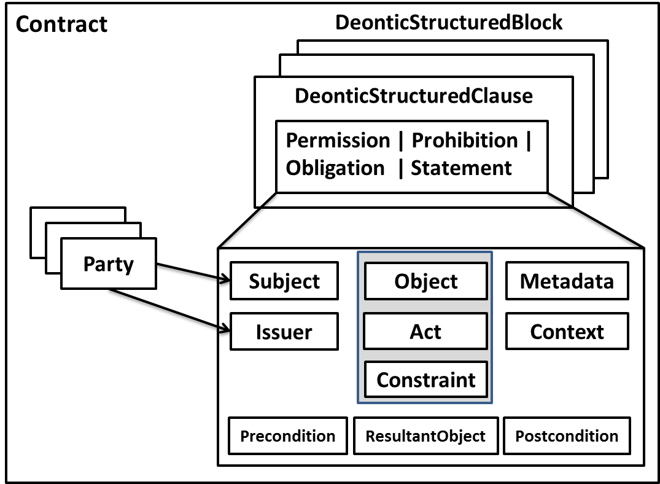
Figure 6. CEL contract general structure
The parties of the contract, who accept and sign it, are expressed as Party, while a right and its conditions is expressed as a DeonticStructuredClause. Actually, we can have four different types of clauses: Permission, Prohibition, Obligation and Statement.
The DeonticStructuredBlock provides the possibility, if desired, to group various clauses, also in multiple levels, and thus replicate the structure of current contracts.
Each deontic structured clause relates the parties in the contract, which can act as Subject or Issuer, with the Object, Act and Constraint present in the clause. In particular, the element Act is used to specify the right, and the element Constraint is used to express the various conditions. Other elements, like Metadata and Context, can be also defined inside the clauses, giving extra information.
Furthermore, the object resulting from applying the Act to the Object under the given Constraint could be defined with the element ResultantObject.
Finally, it is possible to define dependencies between clauses using the Precondition and Postcondition elements. They refer to other clauses that should happen before or after (respectively) the current clause.
Apart from the XML structure outlined here, it is possible to include the text of the original contract inside the XML file and make reference to the text clauses from the XML elements if needed. Then, the relationship between text and operative part (XML) is completely clear. Also secure (encrypted) versions of different elements (for instance, blocks or clauses) can be included in the XML document, to guarantee confidentiality and protection of the contract. Please, refer to the complete text of the standard for further details.
A.2. MCO and its OWL based format
MPEG-21 MCO is written in W3C OWL [9], which is a semantic web language designed to represent rich and complex knowledge about things, groups of things, and relations between things [12], as another MPEG-21 Part, the Media Value Chain Ontology (Part 19) [5], which is used by the MCO itself. Information expressed using OWL technology is retrievable in a deterministic way.
Using the semantic web terminology, we can say that the MCO standard provides the TBox, i.e. the terminological component describing the conceptualization, while each MCO contract/document is a part of the ABox, i.e. the assertion component describing the instances of such concepts, together with the individual relations among them.
As with any other ontology, at the very lowest level, both the MCO standard and each MCO contract are just made of a number of triples, i.e. subject-predicate-object, from which it is possible to derive all the necessary knowledge about the conceptual model, in the case of the standard, and about the contract terms, in the case of the instances.
The main concepts of the MCO model are presented in the diagram of Figure 7, which cannot replace the full reading of the MCO standard text.
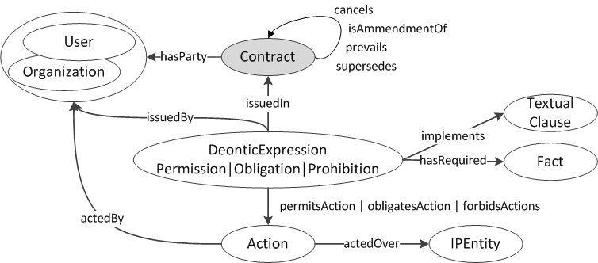

Figure 7. Main elements of MCO Model

The parties of the contract, who accept and sign it, are the User and/or Organization at the end of the hasParty relation.
You will notice that the concept of Permission, used for modeling the right, is part of a wider concept of Deontic Expression, together with the concepts of Obligation and Prohibition. Obligations can be used in several contexts, such as: payments (you might also find Permission requiring Payment to be executed for getting valid), notifications (e.g. about the use of a right or reception of material) or even Obligation to exploit a right (e.g. related to sport events). You might use Prohibitions to express decisions to prevent the use of a right, in particular cases.
The concept of Action, related to a Permission, models the right, the holder of which is the User or Organization found at the end of the actedBy relation.
The issuer of a Permission is the User or Organization who held the right, found at the end of issuedBy relation.
The IPEntity, i.e. Intellectual Property Entity, represents the media content or service object of the right. Some actions can result in new IPEntities.
The conditions which possibly restrict the validity of the Deontic Expression are expressed as required Facts, as explained above. It is also possible to express dependency from the occurrence of a related action or event.
If wished, each Deontic Expression can explicitly point to a Textual Clause. This feature can be used for reporting a mapping to a MCO from an original narrative contract (that can be entirely enclosed as well).

References
[1] OASIS, eContracts Version 1.0 specification, 2007. http://docs.oasis-open.org/legalxml-econtracts/CS01/legalxml-econtracts-specification-1.0.pdf
[2] ISO/IEC 21000: Information technology — Multimedia framework (MPEG-21).
[3] ISO/IEC 21000-20:2013: Information technology — Multimedia framework (MPEG-21) - Part 20: Contract Expression Language.
[4] ISO/IEC 21000-21:2013: Information technology — Multimedia framework (MPEG-21) - Part 21: Media Contract Ontology.
[5] ISO/IEC 21000-19:2010: Information technology — Multimedia framework (MPEG-21) - Part 19: Media Value Chain Ontology.
[6] M. Gisler, K. Stanoevska-Slabeva, and M. Greunz, “Legal Aspects of Electronic Contracts,” Proc. Central Europe Workshop (CEUR-WS), vol. 30, 2000, http://ceur-ws.org/Vol-30/paper7.pdf.
[7] E. Rodríguez, J. Delgado, L. Boch, V. Rodríguez-Doncel, “Media Contracts Formalization Using a Standardized Contract Expression Language”, IEEE Multimedia, ISSN: 1070-986X, Vol. 22(2), pp. 64-74, April 2015.
[8] V. Rodríguez-Doncel, J. Delgado, S. Llorente, E. Rodríguez, L. Boch, “Overview of the MPEG-21 Media Contract Ontology”, Semantic Web Journal, ISSN: 1570-0844, preprint, pp. 1-22, IOS Press, January 2016.
[9] OWL 2, OWL 2 Web Ontology Language Document overview (Second Edition), W3C Recommendation, 11 December 2012, http://www.w3.org/TR/owl2-overview/
[10] OWL 2 Web Ontology Language Primer (Second Edition), W3C Recommendation, 11 December 2012, http://www.w3.org/TR/owl2-primer/
[11] Extensible Markup Language (XML) 1.0 (Fifth Edition), W3C Recommendation, 26 November 2008, http://www.w3.org/TR/xml/
[12] A. Di Carlo et al., “Common Rights Ontology”, PrestoPRIME Project deliverable, https://prestoprimews.ina.fr/public/deliverables/PP_WP4_ID4.0.5b_RightsOntology_R0_v1.11_pp1-142.pdf, August 2010.

A wide corpus of contracts was collected from different sources, involving small and medium enterprises in distinct media industries, such as movie producers, broadcasters, musicians or editors. The legal requirements of the electronic contract [6] were also taken into consideration in this phase.
Online documentation of the MCO Ontology can be found at: http://purl.oclc.org/NET/mco-core
The Media Value Chain Ontology (MVCO) defines various specific sub-classes of IPEntity [5].

